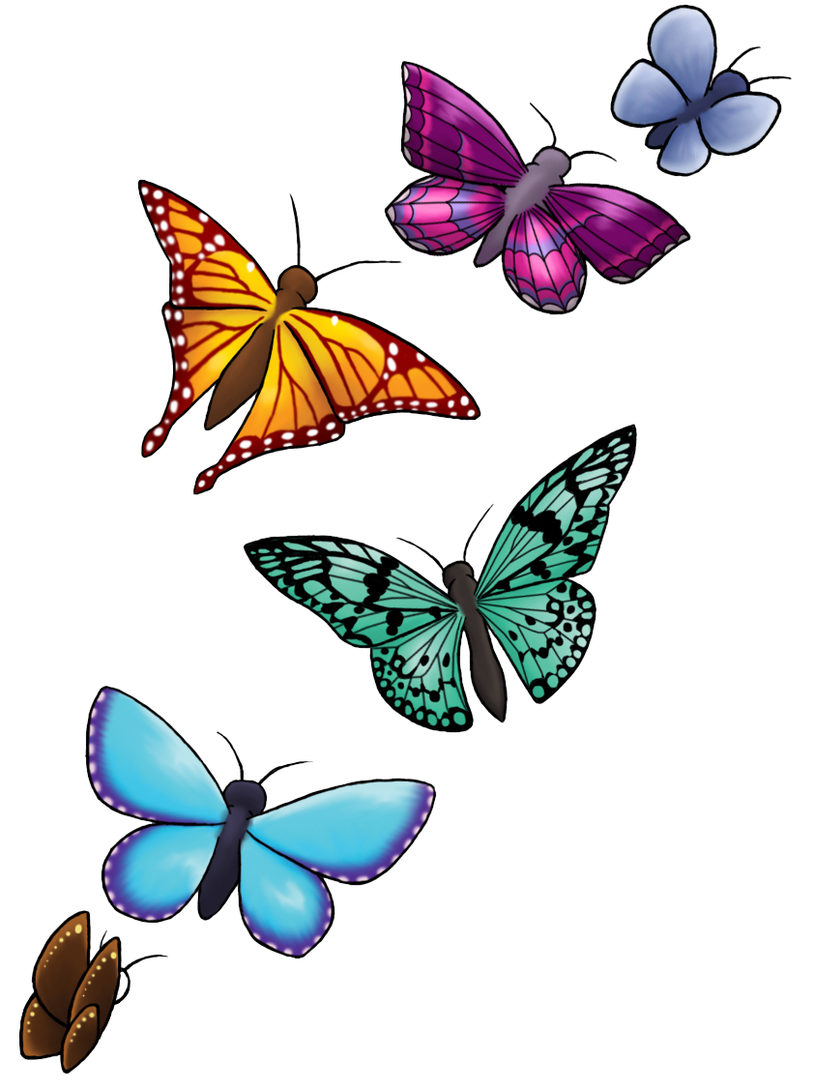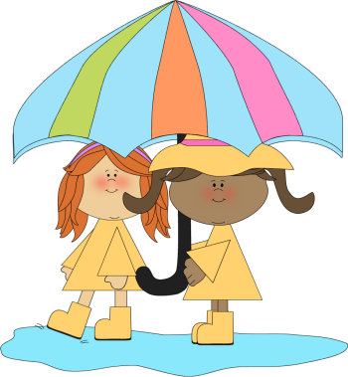

Outdoor Classroom

*Examining our pollinators in our ecosystem

*Execution of the irrigation plans

*Classifying attributes that make a food healthy

April



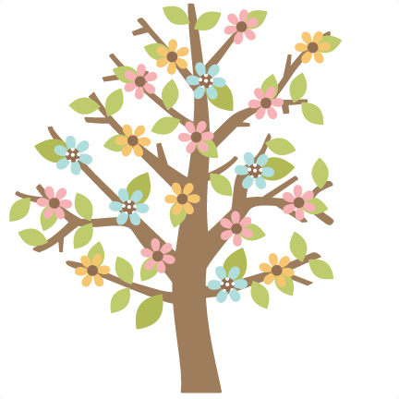

Project Room

*Open ended art

*Constructing maps of the areas around Wonder

Vocabulary: predict, texture and topography

**Ongoing directed learning activities**

Name writing

Letter recognition and sound

Number names and quantity

Handwriting without Tears workbooks

Scholastic Magazine