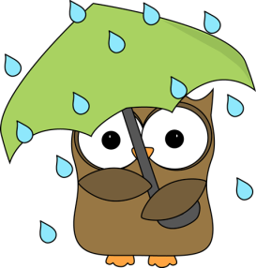****  **Social-Emotional**

**Science**

* Kinetic Sand & molds
* Magnet people
* Seeds & plants
* Frontier Blocks

**Fine Motor**

* Scissor cutting
* Play dough
* Writing Name (signing in every morning)
* Self-regulation (managing feelings,

impulses, and control)

Chooses to play with 1 or 2 “friends”

 **April 2019**

**Speaking & Listening**

* Communicating needs clearly
* Following one or two step directions
* Speak clearly enough for peers and teachers to understand

**Art**

* Word art
* Number art
* Experimenting with grasp & body position using a variety of drawing & writing tools

**Sensory**

* Planting & maintaining plants
* Bird seed, birds, eggs, & nests
* Water with rain clouds or number match

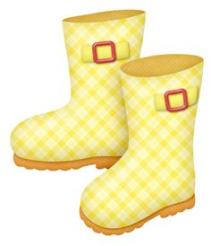

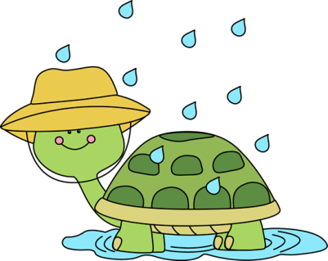

**Math**

* Scales (which is heavier)
* Counting 1-5
* Number recognition

**Collecting**

* 2 Large bags of black beans (uncooked)
* Strawberry baskets
* Soil
* Gardening tools

**Language/Literacy**

* Recognizing first letter in their name
* Recognition of letters
* Begin Name recognition

**Teachers: Ms. Angela & Ms. Michelle**