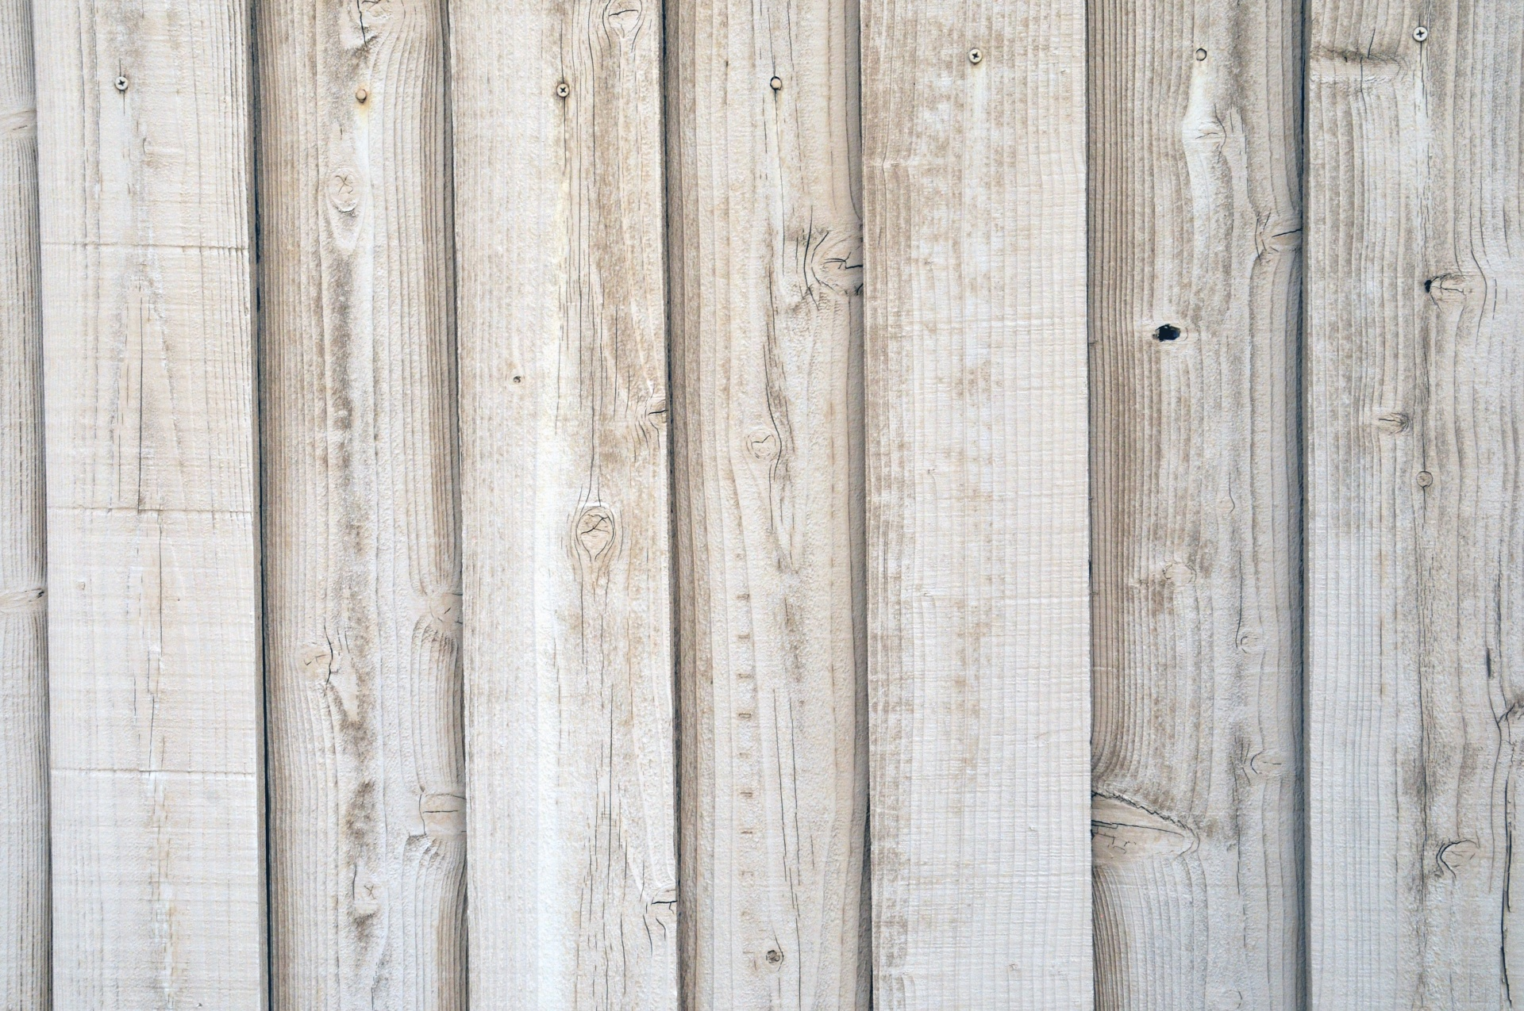
Social-Emotional
Fine Motor
- Tearing paper
- Beginning scissors
*Manages departures & separation from primary care
giver with teacher assistance
*Self regulation. Managing feeling, impulses, and
Art
- Rip art
- Gluing
control

Speaking & Listening
- Following 1 or 2 step directions
- Communicating needs
Outdoor Classroom
- Mud kitchen
- Harvesting our garden
- Exploring trees & animal habitats
- Taking photos of our outdoor classroom

All by Myself
- Put my shoes & socks on
- Wiping nose
- Putting personal items in own cubby
- Trying (no I can’ts)
- Pouring water at snack
Sensory
- Textures (hard, soft, slimy, sticky)

Math
- Small, medium, large
- Counting items (pumpkins, apples, calendar)
Language/Literacy
- Book handling skills
- Please & thank you

Collecting
- Wooden golf tees
- Small portable white board
- Tissues
- Paper towels
- Cream of Tarter
- Gallon Ziplock Bags
- Jingle Bells
- Q-Tips

Teachers: Ms. Angela & Ms. Michelle
Wonder Young K

Pre-Writing
- Scribbling

