

December

Outdoor Classroom/Science

\*Continue investigating properties of solid and non-solid

\*Continue observing the motion of objects and the way they move

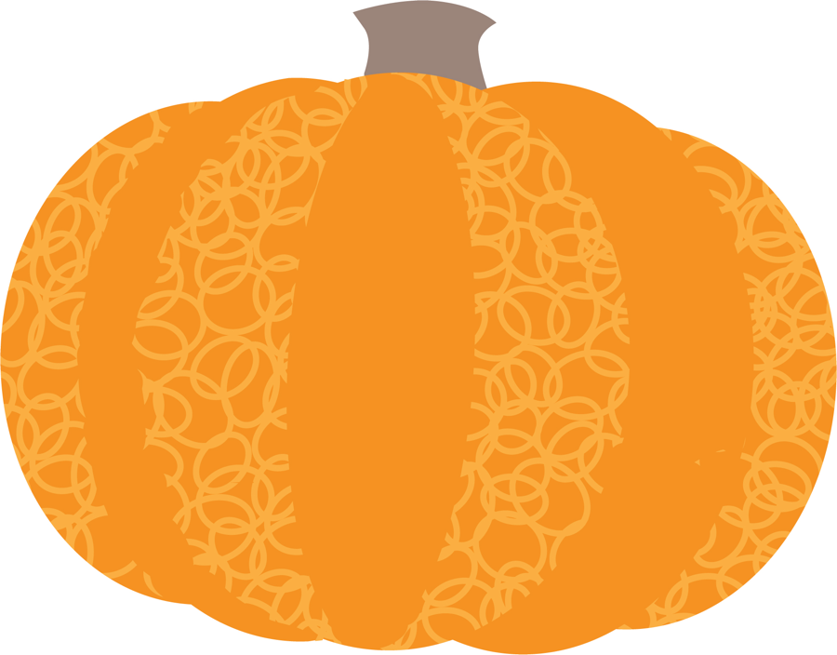

Project Room

\*Choose work to display and be able to give a brief description



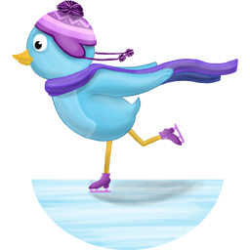

Vocabulary: traditions, cooperation, observation

Directed Learning

Ongoing directed learning activities

Name writing

Letter recognition and sound

Number names and quantity

Handwriting without Tears workbooks

Scholastic Magazine