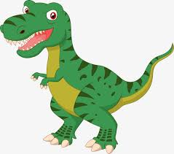

**Language Arts**

* KLW Chart
* Labeling Dinosaur Parts
* Dinosaur Word Cards (pre-reading)
* Beginning sound of Dinosaur Parts
* Variety of Dinosaur Books

**Teacher**

Ms. Lynn

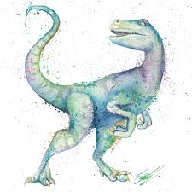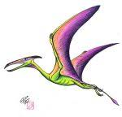21112

**Science**

* Fossils and Bones
* What is a Paleontologist?

**Music and Movement**

* We are the Dinosaurs Marching
* Dinosaur ABC Song
* Story Bots on Dinosaurs