

Outdoor Classroom

* Children are working collaboratively with an assortment of materials to create different types of homes.

*Continue navigating their way around the garden to find and write their peers’ names.

February



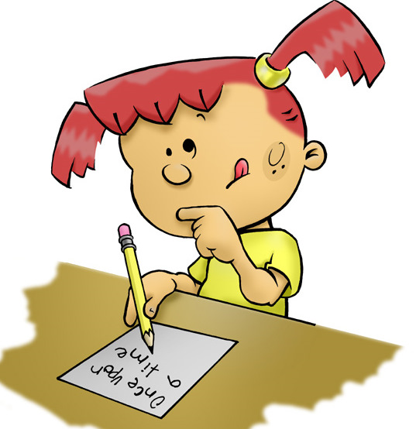

Project Room

*Continue to choose work to display and give a brief description

*Children begin to plan their art

*Draw more detailed figures or objects with control of line and shape.

**Ongoing directed learning activities**

Name writing

Letter recognition and sound

Number names and quantity

Handwriting without Tears workbooks

Scholastic Magazine

Vocabulary: collection replicate and architect