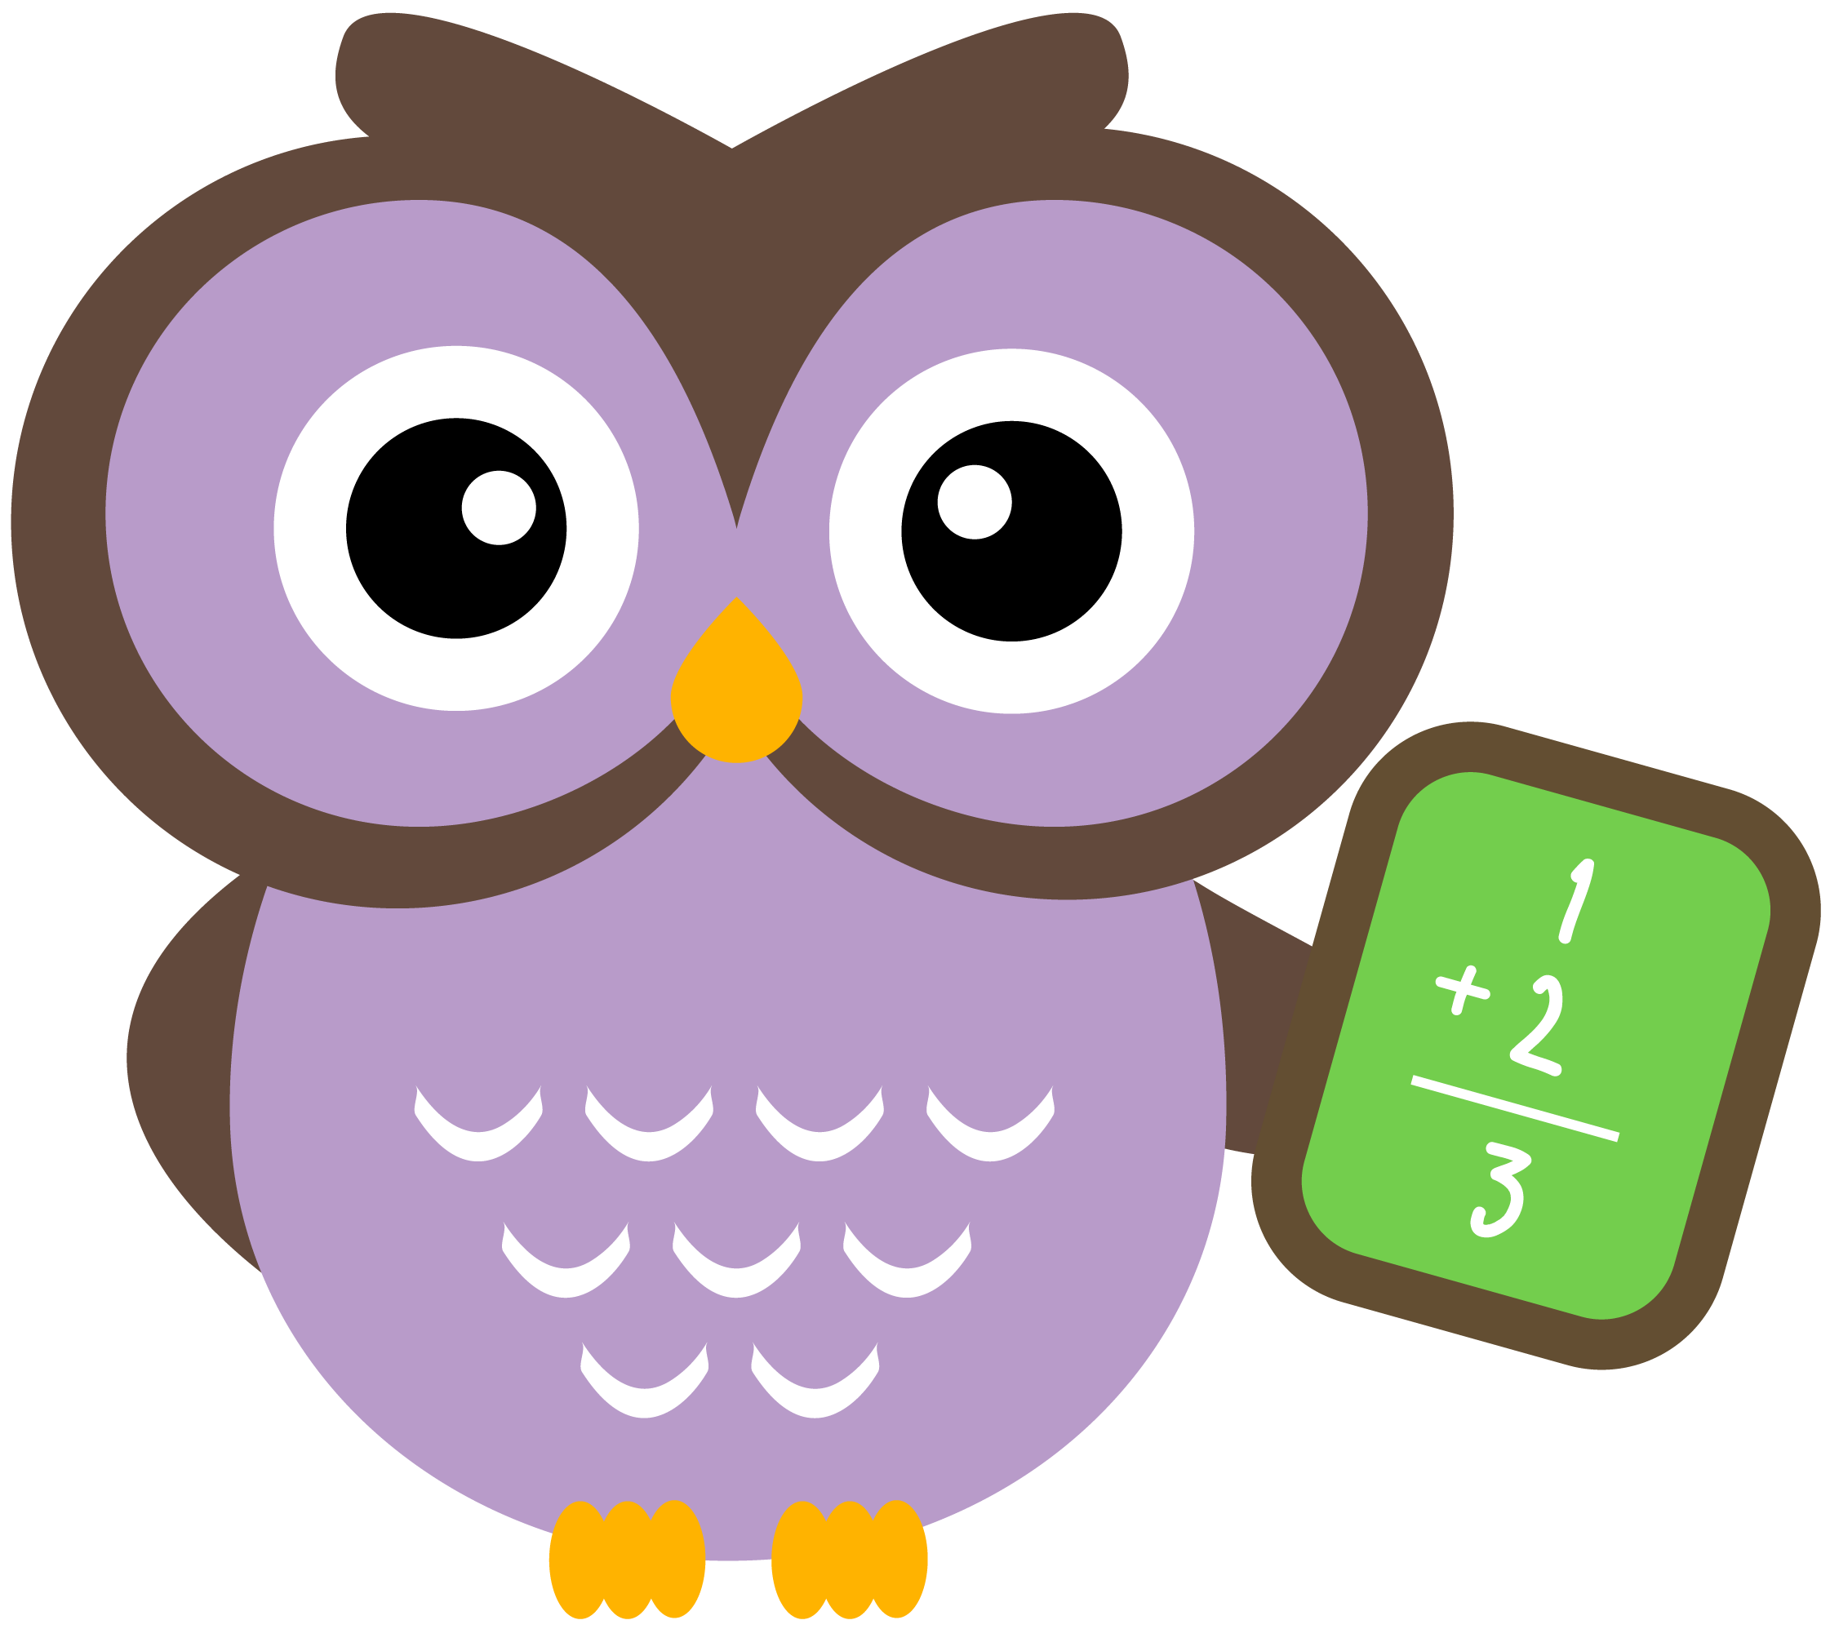

Outdoor Classroom

*Caring for the natural world (recycle, cleaning up our trash and not wasting)

*Explore effects of motion in the sandbox (pushing, pulling, rolling and dropping)

January







Project Room

*Plan and design sculptures

*Recognize names of materials and tools



Vocabulary: recycle, motion and materials

**Ongoing directed learning activities**

Name writing

Letter recognition and sound

Number names and quantity

Handwriting without Tears workbooks

Scholastic Magazine