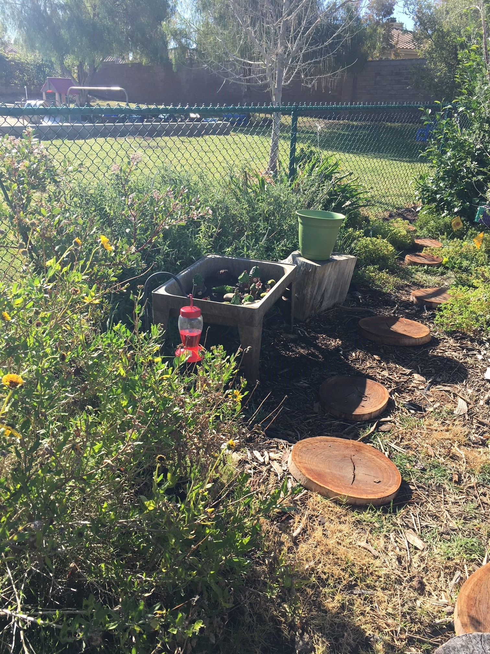
Social-Emotional
May/June 2018
Outdoor Classroom
- Sensory garden
- Mud kitchen
- Making mud
- Observing & recording our caterpillars
- Sharing

- Using words to problem solve

All by Myself
- Washing hands
- Pulling one paper towel for drying
- Water plants
Math
- Measuring garden sprouts
- Symmetry butterflies

Sensory
- Exploring our 5 sense
  - Seeing
  - Smelling
  - Tasting
  - Feeling
  - Hearing
Pre-Writing
- Writing name
- Finding the letters to make our name or other names
- Word wall

Fine Motor
- Tweezers & Bugs
- Markers

Art
- Egg carton caterpillars
- Butterflies

Collecting
- Newspaper
- White glue
- Glue sticks

Language/Literacy
- Very Hungry Caterpillar
- Retelling books
Teachers: Ms. Angela & Ms. Michelle
Wonder Young K

