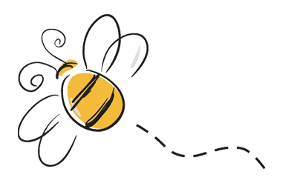

**Outdoor Classroom**

*Observing pollinators as they move about the garden

*Rhyming in the garden

**Ongoing Directed Learning**

*Name writing

*Handwriting Without Tears

*Scholastic Magazine

Wonder Pre-K

Classroom Curriculum April

**Gross Motor**

*Bouncing

*Catching

**Project Room**

*Children select art for display and write about it.

*Sewing

**Language and Literacy**

* Generating rhyming words

*Letter matching upper and lower case

*Story retelling

**Math**

*Identify AB patterns in our everyday environment

* Manipulate parts of a whole

*Introduce Venn graphs