**Language Arts**

* KWL Chart
* Group Story:

**Outside Adventures**

* **Books to Read:**

1. The Tiny Seed
2. We’re Going on a Nature Hunt
3. Ladybug on the Move
4. Farfallina & Marcel
5. The Earth & I
6. Animal Tracks
7. Wonderful Nature,

Wonderful You

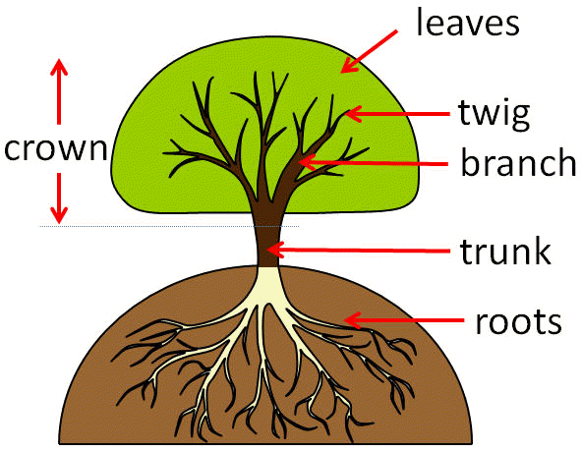

**Music and Movement**

* Hiking and exploring the outside of Wonder
* Observing and imitating nature

**Songs**:

* Itsy Weensy Spider
* Five Little Ducks

**Science**

* What is nature?
* What animals or insects do we see outside & what do they need to survive?
* What do trees, plants flowers need to live?

**Ms. Lynn**