Social-Emotional
Fine Motor
- Tearing Paper
- Scissors
- Manages departures & separation from primary care
Art
- Exploring textured paints
- Tearing & Ripping
- Experimenting with grasp & body position using a variety of drawing & writing tools
giver with teacher assistance
- Self-regulation (managing feelings, impulses, and
control)
November 2017
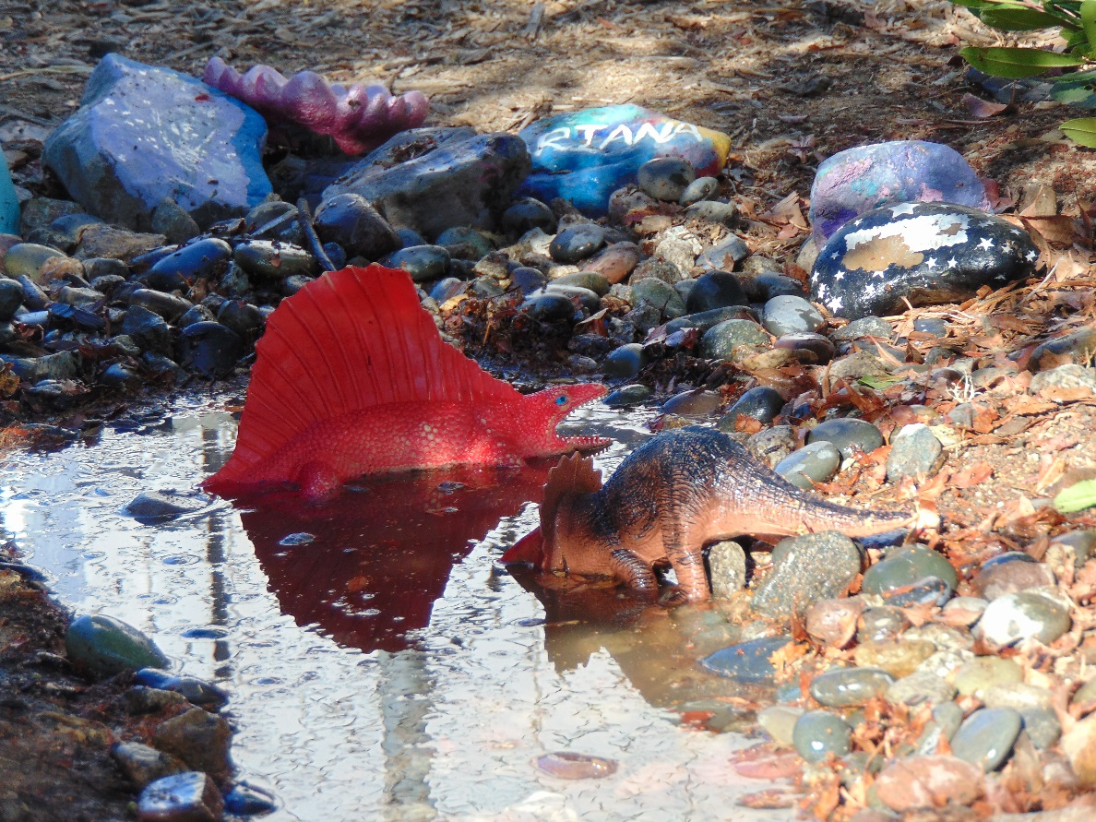
Speaking & Listening
- Communicating needs
- Following one step directions

Outdoor Classroom
- Gardening and planting preparation
- Shoveling & Raking
- Scooping & Dumping

Sensory
- Textures
- Water play/Bubbles

Language/Literacy
- Display appropriate book handling skills
- Begin to recognize the first letter in their name
Collecting
- Family Photos
- Soil
- Burlap & Ribbon
- Bubble Wrap
- White Cardstock

Teachers: Ms. Angela & Ms. Michelle
Wonder Young K

