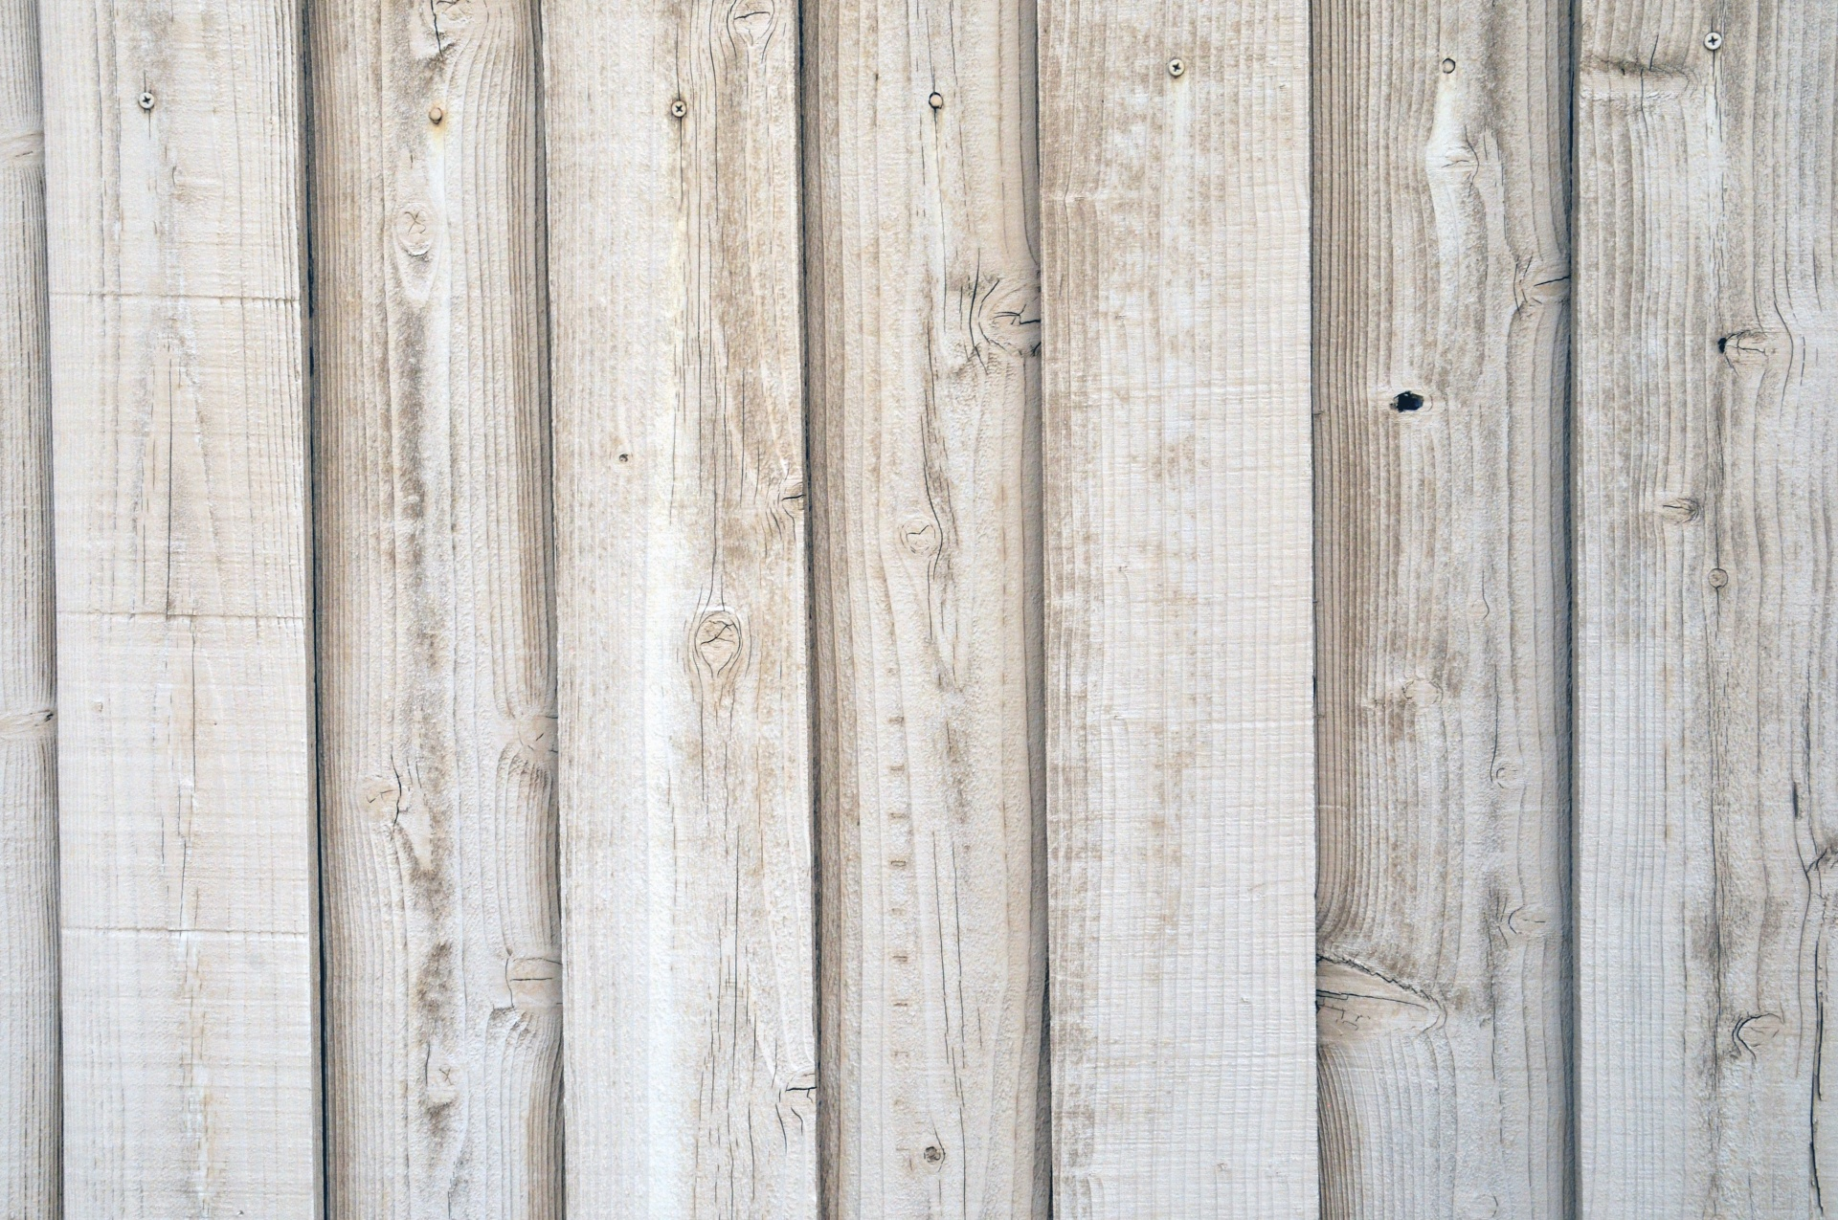
Social-Emotional (Emotion Regulation)
Fine Motor
- Using crayons to draw lines & circles on a piece of paper
- Turn pages of a paperback book one page at a time
- Asking teacher to help say good bye to parent at
drop off
- Establishing daily care routine to help regulate mood
Art
- Exploring paints
- Mixing colors
- Beginning glue

Speaking & Listening (Communication skills & knowledge)
- Answer questions such as “what’s that?” & “where did it go?”
- Participate in back & forth interactions with teachers

Outdoor Classroom (Gross motor)
- Obstacle course for climbing
- Planting
- Nature exploration

Math (Number sense & classification)
- Counting to 5 (1:1 correspondence)
- Classification & sorting apples/pumpkins by color & size
Personal Care Routine
- Go to sink & wash hands
- Get tissue & take care of nose
- Put shoes on & off

Sensory
- Water & pouring
- Using recipe to make mud

Pre-Writing
- Scribbling
Collecting
- Mini pinecones
- Mini acorns
- Assorted beans (bag)
- Clorox Wipes

Language/Literacy (Interest in print)
- Try to be careful with books
- Enjoy both being read to and looking at books themselves

Teachers: Ms. Angela & Ms. Michelle
Wonder Young K

