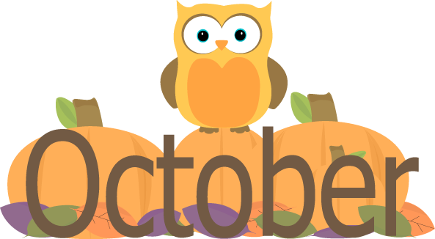
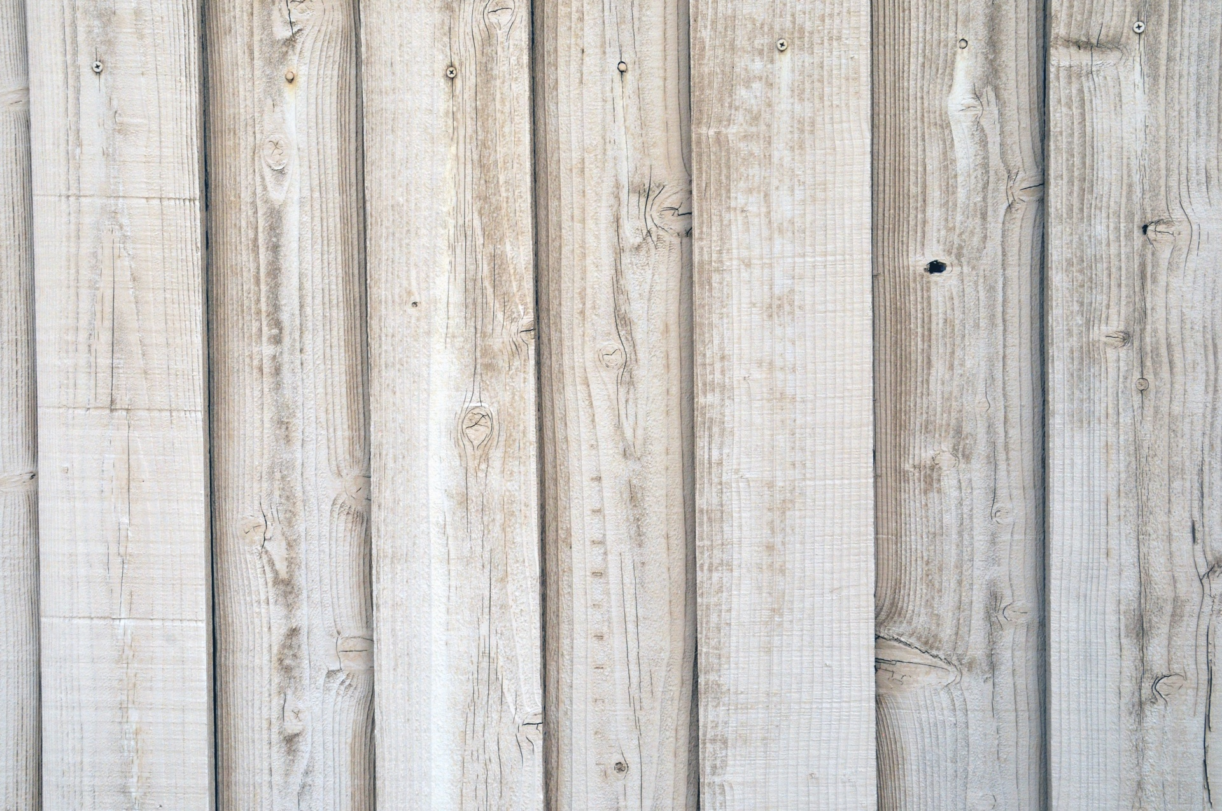
Social-Emotional
Fine Motor
- Holding chubby crayons
- Knob puzzles
- *Manages departures & separation from primary care
giver with teacher assistance
- Choose to play with one or two children whom
they identify as peers
Art
- Exploring paints
- Beginning glue

Speaking & Listening
- Following 1 step directions
- Communicating needs

Outdoor Classroom
- Creek exploration
- Mud kitchen
- Beginning gardening skills

All by Myself
- Put my shoes on
- Restroom (i.e., dressing, wiping, and washing hands)
- Pulling paper towels from dispenser

Sensory
- Water & pouring
- Playdough

Math
- Positional Math (in front, next to, behind)

Pre-Writing
- Scribbling
Collecting
- Pumpkins (assorted shapes, sizes, colors)
- Eggs
- 2 hay bails
- Gourds

Language/Literacy
- Choosing a book
- Book handling skills

Teachers: Ms. Angela & Ms. Michelle
Wonder Young K

