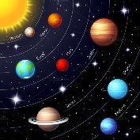

**Language Arts**

* Story Bots: We Are the Planets
* Rocket Names
* Selected Books:

1. Planets in Our Solar System
2. The Moon
3. The Sun
4. The Stars
5. The Planets
6. Solar System
7. Discovering Stars
8. My Book of Planets

Teacher:

Miss Lynn

**Science**

* Cycles of the Moon
* Orbits Around the Sun
* KWL Chart

**Teacher**

**Ms. Lynn**

**Fine Motor Skills**

* **Fine Motor** (drawing, writing, tracing & cutting)
* ***Gross Motor*** (Music & Movement)
* **Writing** (Names on Rockets)
* **Creativity** (Brainstorming)