**Language Arts**

* KWL Chart
* Sharing Ideas…What pets do we have or want?
* **Selected Books to Read:**

1. My Favorite Pets
2. Just Me & My Puppy
3. Favorite Pets
4. Caring for Your Pets
5. The Big Pets
6. Teach Me About Pets
7. Caring for Pets

**Teacher: Miss Lynn**

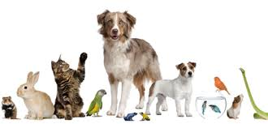

**Science**

* Constructing a pet home
* Group chart for pet care

**Music and Movement**

**Songs:**

* B-I­­-N-G-O
* Farmer in the Del
* My Dog Wags
* Let’s pretend we are different pets.